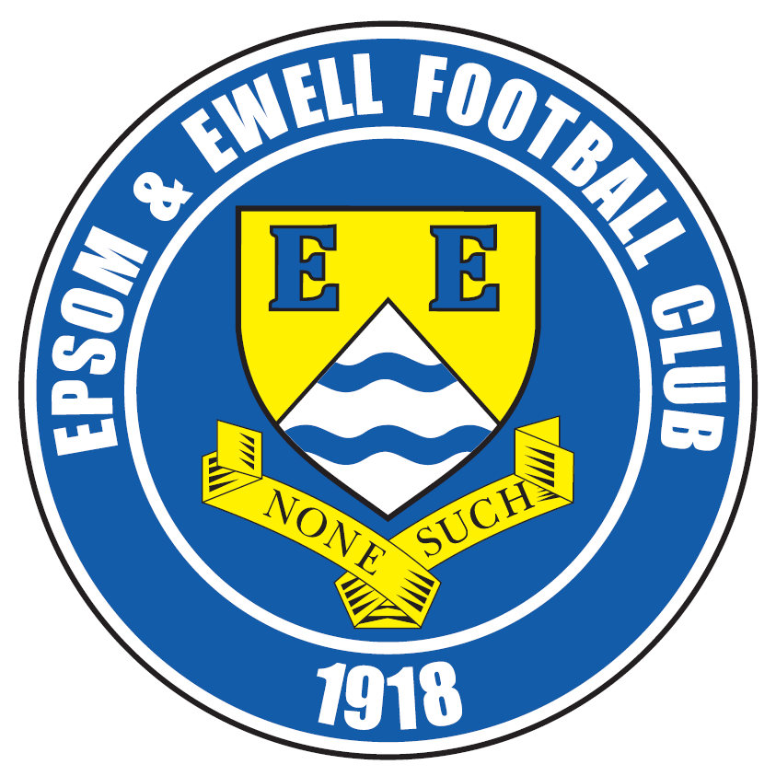 | Epsom & Ewell F.C.  3  v  Abbey Rangers  Tuesday, 23rd August 2016 – 7.45 p.m.
Good evening and welcome to High Road for our home League match against Abbey Rangers. We welcome their players, supporters and officials, and of course our own followers.

Although this is our first ever meeting, we are due to meet them here again in just two weeks for a League Cup tie with the return League match scheduled for December. They are very local to us, almost on Chertsey Town’s doorstep and I can confirm from the Combined Counties League Annual General Meeting there in June that the hospitality provided is excellent, so it is well worth making the effort to visit later in the season.

Last Tuesday we hosted another of the promoted clubs in CB Hounslow United, and the result couldn’t have been more different to our match at Bedfont & Feltham as we faded badly after a bright start to lose 5-1 here.

Of course we visited Faversham Town in the F.A. Cup on Saturday, and we led for almost an hour, but fell to a 2-1 defeat in the end. It is always tough to go out of the F.A. Cup with the financial incentives it brings, but we had a really good go at a team that are regulars at the business end of the Ryman League South Division.

Moving forward, on Friday evening at 7.30 we visit Colliers Wood United and this will provide an extra day’s recovery time before we host Horley Town on the Bank Holiday Monday morning. This match takes place at 11.30 a.m. so don’t bother turning up for a 3pm kick off as we will have all gone home!

Looking further ahead our home match with Guildford City is to be moved from Tuesday 13th September to the 17th January as Chipstead have a Ryman League Cup tie that day, while our trip to Westfield will now take place on Tuesday 27th September, Additionally, it is looking increasingly likely that we will have no game on Saturday 3rd September. These things happen!

We are celebrating a special anniversary today of something that happened in 1986. Further details follow later on but I wonder if you can guess what it might be!

Enjoy the game!

Rich

You can follow us on Facebook: www.facebook.com/epsomandewellfc Twitter: @EEFCOfficial and
Instagram at: www.instagram.com/epsomandewellfc We also have a Youtube channel now!

Cover photos by Gemma Jarman

- Daryl Cooper-Smith puts us ahead at Windsor on 13th August

- Daryl seems fairly happy about his goal!


Cherry Red Records Combined Counties League
Premier Division Table 2016/17
including Saturday 20th August | P | W | D | L | F | A | Pts | GD | H | A
Hartley Wintney | 4 | 3 | 0 | 1 | 9 | 5 | 9 | +4 | 18/3 | 10/12
Windsor | 3 | 3 | 0 | 0 | 9 | 5 | 9 | +4 | 15/11 | 1-2
Hanworth Villa | 3 | 2 | 1 | 0 | 7 | 4 | 7 | +3 | 13/12 | 14/1
Camberley Town | 3 | 2 | 0 | 1 | 11 | 5 | 6 | +6 | 10/9 | 1/4
Westfield | 2 | 2 | 0 | 0 | 6 | 0 | 6 | +6 | 18/2 | 27/9
Horley Town | 3 | 1 | 2 | 0 | 6 | 4 | 5 | +2 | 29/8 | 17/4
Bedfont Sports | 2 | 1 | 1 | 0 | 5 | 4 | 4 | +1 | 19/11 | 7/2
Walton & Hersham | 2 | 1 | 1 | 0 | 2 | 1 | 4 | +1 | 4/3 | 1/10
Spelthorne Sports | 2 | 1 | 1 | 0 | 1 | 0 | 4 | +1 | 7/1 | 25/2
Badshot Lea | 4 | 1 | 1 | 2 | 5 | 9 | 4 | -4 | 4/2 | 17/9
Epsom & Ewell | 3 | 1 | 0 | 2 | 11 | 9 | 3 | +2 | X | X
North Greenford United | 3 | 1 | 0 | 2 | 5 | 4 | 3 | +1 | 22/4 | 15/10
Guildford City | 2 | 1 | 0 | 1 | 6 | 6 | 3 | 0 | 17/1 | 5/11
Abbey Rangers | 2 | 1 | 0 | 1 | 5 | 5 | 3 | 0 | 23/8 | 3/12
Knaphill | 2 | 1 | 0 | 1 | 4 | 4 | 3 | 0 | 24/9 | 8/4
Chertsey Town | 2 | 1 | 0 | 1 | 2 | 3 | 3 | -1 | 17/12 | 11/2
AFC Hayes | 2 | 1 | 0 | 1 | 2 | 3 | 3 | -1 | 26/11 | 28/1
CB Hounslow United | 4 | 1 | 0 | 3 | 6 | 8 | 3 | -2 | 1-5 | 12/11
Farnham Town | 4 | 1 | 0 | 3 | 5 | 10 | 3 | -5 | 25/3 | 8/10
Bedfont & Feltham | 4 | 1 | 0 | 3 | 6 | 17 | 3 | -11 | 21/1 | 9-2
Raynes Park Vale | 3 | 0 | 1 | 2 | 3 | 5 | 1 | -2 | 27/12 | 25/10
Sutton Common Rovers | 2 | 0 | 1 | 1 | 1 | 3 | 1 | -2 | 8/11 | 2/1
Colliers Wood United | 3 | 0 | 1 | 2 | 4 | 7 | 1 | -3 | 14/4 | 26/8

Lucky Day? – 23rd August
Played 19 - Won 5 Drawn 7 Lost 7 - For 36 Against 35 - Points Per Game 1.16
Our Club record against Abbey Rangers
The two clubs have never met

First Eleven Appearances 2016/17 - (max 5)
Name | Debut | 2016/17 |  |  |  | Career Totals
Name | Debut | App | Sub | Total | Goals | App | Sub | Total | Goals
COOPER-SMITH Daryl | 03/01/2015 | 5 | 0 | 5 | 6 | 35 | 8 | 43 | 26
DEAN Dan | 02/08/2014 | 2 | 0 | 2 | 0 | 70 | 4 | 74 | 2
EACOTT Michael | 02/08/2014 | 4 | 0 | 4 | 0 | 89 | 1 | 90 | 0
FARRELL Matt | 02/08/2014 | 5 | 0 | 5 | 3 | 91 | 4 | 95 | 21
FERDINANDO Matt | 20/09/2014 | 2 | 1 | 3 | 0 | 55 | 7 | 62 | 14
GALLAGHER Jordan | 07/08/2016 | 1 | 2 | 3 | 1 | 1 | 2 | 3 | 1
GRIFFIN Reisse | 08/08/2015 | 3 | 1 | 4 | 0 | 31 | 7 | 38 | 2
HASTINGS Craig | 08/08/2015 | 5 | 0 | 5 | 0 | 42 | 4 | 46 | 0
HEAGNEY Adam | 16/08/2015 | 0 | 2 | 2 | 0 | 0 | 2 | 2 | 0
HENDRY Rob | 08/08/2015 | 4 | 1 | 5 | 1 | 34 | 12 | 46 | 13
MCKAY Alex | 20/12/2008 | 1 | 2 | 3 | 0 | 109 | 32 | 141 | 8
NEALE Tom | 13/10/2015 | 3 | 2 | 5 | 4 | 19 | 21 | 40 | 14
NORTH Rhys | 16/08/2015 | 2 | 1 | 3 | 0 | 19 | 8 | 27 | 1
PANAYIOTOU Savvas | 03/01/2015 | 0 | 2 | 2 | 0 | 32 | 10 | 42 | 7
ROBINSON Sam | 22/10/2011 | 3 | 1 | 4 | 1 | 57 | 6 | 63 | 14
TANTON Matt | 02/08/2014 | 5 | 0 | 5 | 0 | 62 | 4 | 66 | 2
TAYLOR James | 26/08/2013 | 5 | 0 | 5 | 0 | 91 | 12 | 103 | 6
THOMPSON Elliott | 09/02/2016 | 3 | 0 | 3 | 1 | 7 | 9 | 16 | 1
TURPIE Alistair | 31/03/2016 | 1 | 0 | 1 | 0 | 3 | 0 | 3 | 0
WATRET Jack | 02/08/2016 | 1 | 0 | 1 | 0 | 1 | 0 | 1 | 0
* Player has left the club

Latest Results and Fixtures
Combined Counties League – Monday 15th August
Sutton Common Rovers | 1-1 | Horley Town
Combined Counties League – Tuesday 16th August
Badshot Lea | 2-1 | Knaphill
Bedfont & Feltham | 1-3 | Abbey Rangers
Chertsey Town | 0-3 | Westfield
Epsom & Ewell | 1-5 | CB Hounslow United
Farnham Town | 1-4 | Camberley Town
North Greenford United | 1-2 | Walton & Hersham
Raynes Park Vale | 0-1 | Spelthorne Sports
Windsor | 4-2 | Guildford City
Combined Counties League – Wednesday 17th August
Bedfont Sports | 2-2 | Hanworth Villa
Colliers Wood United | 1-2 | Hartley Wintney
Emirates F.A. Cup Preliminary Round – Saturday 20th August
Badshot Lea | 0-4 | Cray Wanderers
Banstead Athletic | 3-3 | Colliers Wood United
Bishops Cleeve | 1-1 | Camberley Town
Carshalton Athletic | 3-0 | Farnham Town
CB Hounslow United | 2-1 | Petersfield Town
Chertsey Town | 3-0 | AFC Hayes
Faversham Town | 2-1 | Epsom & Ewell
Greenwich Borough | 1-1 | Walton & Hersham
Guildford City | 1-1 | Chessington & Hook United
North Greenford United | 4-1 | Kidlington
Slimbridge | 3-0 | Bedfont Sports
Spelthorne Sports | 2-3 | Andover Town
Wantage Town | 4-2 | Hanworth Villa
Combined Counties League – Saturday 20th August
Hartley Wintney | 2-3 | Bedfont & Feltham
Raynes Park Vale | 2-3 | Windsor
Emirates F.A. Cup Preliminary Round Replay – Tuesday 23rd August
Colliers Wood United | V | Banstead Athletic
Camberley Town | V | Bishops Cleeve
Walton & Hersham | V | Greenwich Borough
Chessington & Hook United | V | Guildford City
Combined Counties League – Tuesday 23rd August
AFC Hayes | V | Hanworth Villa
CB Hounslow United | V | Badshot Lea
Epsom & Ewell | V | Abbey Rangers
Latest Results and Fixtures
Combined Counties League – Tuesday 23rd August
Knaphill | V | Raynes Park Vale
Windsor | V | Bedfont Sports
Combined Counties League – Friday 26th August
Colliers Wood United | V | Epsom & Ewell
Combined Counties League – Saturday 27th August
Abbey Rangers | V | Bedfont Sports
Badshot Lea | V | Westfield
Bedfont & Feltham | V | Raynes Park Vale
Camberley Town | V | Chertsey Town
Farnham Town | V | Spelthorne Sports
Horley Town | V | Hanworth Villa
Knaphill | V | AFC Hayes
North Greenford United | V | Windsor
Sutton Common Rovers | V | Hartley Wintney
Walton & Hersham | V | Guildford City
Combined Counties League – Monday 29th August
AFC Hayes | 3pm | North Greenford United
Bedfont Sports | 11.30am | Bedfont & Feltham
Chertsey Town | 11.30am | Abbey Rangers
Epsom & Ewell | 11.30am | Horley Town
Guildford City | 11.30am | Badshot Lea
Hanworth Villa | 11.30am | CB Hounslow United
Hartley Wintney | 11.30am | Camberley Town
Spelthorne Sports | 11.30am | Knaphill
Westfield | 11.30am | Farnham Town
Windsor | 11.30am | Walton & Hersham
Combined Counties League – Tuesday 30th August
Raynes Park Vale | V | Colliers Wood United
Emirates F.A. Cup First Qualifying Round – Saturday 3rd September
Bishops Cleeve / Camberley Town | V | Cray Valley (PM) / Hastings United
CB Hounslow United | V | Met Police
Guernsey / Thamesmead Town | V | Chertsey Town
Colliers Wood United /  Banstead Athletic | V | Whitstable Town /  Eastbourne Town
Bognor Regis Town | V | Guildford City /  Chessington & Hook United
Folkestone Invicta | V | North Greenford United
Walton Casuals / Chatham Town | V | Greenwich Borough /  Walton & Hersham

From behind the goal
Epsom & Ewell 1-5 CB Hounslow United
Combined Counties League - Premier Division - Tuesday 16th August 2016

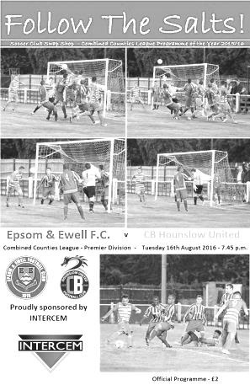

Salts struggle at home again as CB Hounslow finish deserved winners

By the end of this match, our boys looked extremely dispirited and understandably so. Promoted last season and with a very similar record to Bedfont & Feltham who we defeated heavily just two weeks ago, maybe some people thought this match against CB Hounslow United would be a walk in the park. It certainly wasn't, and by the end a scoreline of 5-1 told its own story as the visitors claimed their first points of the season at the fourth attempt.

Aiming to bounce back from the narrow defeat at Windsor we were forced into a number of changes. Both Elliott Thompson and Matt Ferdinando were unable to recover from their injuries at Stag Meadow with Thompson awaiting an MRI scan on his injured ankle, while Alex McKay joined the absent list along with Dan Dean who was still on holiday. James Taylor moved alongside Craig Hastings with Rhys North coming in at right back, while Reisse Griffin and Tom Neale came into the starting eleven as did Jordan Gallagher at the expense of Rob Hendry who was on the bench.

Despite the rearrangements, we started the match quite well. Neale had a couple of early chances but went for power instead of accuracy and missed the target on both occasions. Taylor headed over the bar from a Sam Robinson corner before the visitors forced Michael Eacott into action with a good low save for a corner but we were back on the attack as Gallagher made tracks down the left and beat his man before laying the ball up for Daryl Cooper-Smith, who was unfortunate to see his goal bound shot from 15 yards deflect for a corner off the knee of a defender.

If this was unfortunate, we were very unlucky when we had a penalty shout turned down in the 12th minute when Cooper-Smith and a CB Hounslow defender both went for the ball in the penalty area. Our man just got a toe to it ahead of the defender, and you could see this by the direction the ball went, before being clattered, but the referee for some reason was unimpressed. Three minutes later and following further Epsom pressure, Matt Farrell struck a shot from the edge of the area that was kept out by Alex Wines, who got down low to his right; turning the ball around the post for a corner, despite appearing to be unsighted at first. A really special save.

Reisse Griffin also appeared to be impeded in the box after 22 minutes following a dangerous Robinson free kick, but after failing to win the earlier penalty you knew that one wouldn't be forthcoming this time as this one was less obvious. Cooper-Smith poked an effort wide from just inside the box but despite all of the pressure to that

point, it was the visitors who then took the lead in the 25th minute. Terence Cariba got in behind our defence and calmly finished off with a low strike just inside Eacott's right hand post. I was informed by people in a better position that Craig Hastings was fouled in the act of clearing the ball, which would explain how Cariba got through so easily.

In that moment the game changed. Our intensity, which had been really good, dropped considerably while the visitors started to play some nice football themselves and there was little more to report on before the interval except a few yellow cards, the first two for Matt Tanton and Tommy O'Neill for the visitors looked extremely harsh.

We were nearly back on terms in the opening seconds of the new half as a Robinson free kick on the edge of the area took a slight deflection and Neale was in on the loose ball but Wines was able to block the effort, securing himself a sore hand in the process. The game began to open up a little and Eacott made a fine full stretch save for a corner from an unmarked header before Cooper-Smith had arguably the best chance of the night, but from a central position just twelve yards out, his powerful effort was straight at the grateful keeper who was able to parry the ball to safety.

This miss was crucial. In the 57th minute we lost the ball in midfield when two players left it for each other and the break down the right was squared for Ronnie Bangato to score easily from close range. Four minutes later we conceded from an own goal. It was hard to see exactly what happened but a long throw was flicked on into the danger area and Eacott got a hand to the ball but whether it went into the net directly from that or off a defender I couldn't say. Either way it was game over and within two minutes it was 4-0 as Cariba smashed a ball into the top corner from just inside the box. It was a great finish but there was, yet again a complete absence of marking.

Three substitutes joined the fray at this point, which tells you what the Management thought, and it must be said things improved a little from an Epsom perspective. Not that this made any difference to the officiating as a defensive header out for a rare corner was completely missed by both officials, also failing to spot the fact that both teams were walking back to take their positions for the set piece However, by then the damage had already been done and whilst subs Hendry and Adam Heagney had combined well with the latter on his debut finding Neale who guided the ball in from six yards in the 82nd minute, we still let the opposition restore the four goal advantage with an 89th minute goal; Cariba completing his hat trick after some poor defending.

There is really nothing positive to take from this defeat, our third home league defeat in a row dating back to last season and our heaviest since Windsor inflicted a 5-0 defeat in January 2015. Maybe we deserved better for our early first half showing, but we have to perform for the full 90 minutes if we really want to compete with the leaders of this division. On this performance, a lower half finishing position appears more likely.

Epsom and Ewell: Michael Eacott, Rhys North, Matt Tanton. James Taylor, Craig Hastings, Sam Robinson, Jordan Gallagher, Matt Farrell (c), Tom Neale, Daryl Cooper-Smith,
Reisse Griffin
Subs: Rob Hendry for Cooper-Smith (65), Savvas 'Agi' Panayiotou for Gallagher (65),
Adam Heagney for Tanton (65)

From behind the goal
Faversham Town 2-1 Epsom & Ewell
Emirates F.A. Cup Preliminary Round - Saturday 20th August 2016

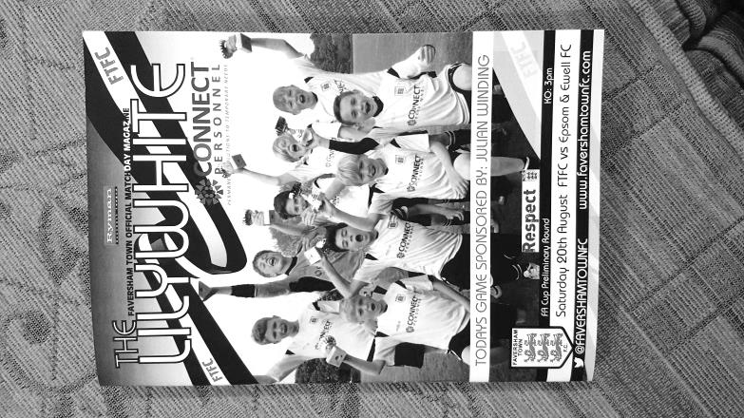
Faversham finally break down Salts resistance

Bearing in mind that Step Six Gravesham Borough are the only team from Kent that we have beaten since the year 2000, and that Faversham play a level above us in the Ryman League, it was no real surprise that we were knocked out of the F.A. Cup and deservedly so on the balance of the ninety minutes play. However, we were well in this match for a long time and on another day maybe we would have held on to our early lead to earn a home tie against Cray Wanderers.

Following our horror show at home to CB Hounslow United on Tuesday further changes were required. Reisse Griffin had suffered a nasty cut and was unable to make the trip, while both Michael Eacott and Jordan Gallagher found themselves on the bench, although arguably it could have been any of the eleven starters. Rob Hendry and Matt Ferdinando came into the starting line-up, hopefully to provide us with more of an attacking threat while Alistair Turpie came in between the posts.

The first minutes were quite even. The home side, playing in their away kit of gold and black, swept a shot across Turpie's goal while Tom Neale got a shot on target but Will Godmon was well positioned to make the save. The game swung from end to end but on a windy day little of quality was created with exception of the 13th minute when we earned a corner, despite the home team's protestations. Hendry delivered a dangerous set piece which wasn't claimed and the ball bounced in the six yard box until Neale reached it first and his attempt went up into the net, but it wasn't clear that it had crossed the line at first and a defender headed the ball out, but unfortunately for him only succeeded in knocking it against his team mate with the ball rebounding into the net to remove any element of doubt, although it was credited to Neale.

We were playing well at this point. Chasing everything down it was clear that any hangover from Tuesday's match was forgotten and we were making our hosts work for every yard. This didn't stop them from creating chances but apart from one effort that was deflected for a corner by Matt Farrell there was little for Turpie to get concerned about. However, when Neale pulled up on the sideline in the 31st minute with a pulled hamstring our options became limited. Hendry was moved into a more central role with Agi Panayiotou coming in on the left hand side but we were never quite the same after this.

As the second half commenced it was apparent that we had been against quite a strong wind in the first half and would have it in our favour for the second period. It wasn't exactly end to end but it would surely help us. Daryl Cooper-Smith clearly thought so and when he was put away on the right in the opening seconds he tried a speculative effort from 25 yards which was at the perfect height and not that far wide either.

However, this was going to be a long half for Epsom supporters, many of whom had made the journey East. The home side started to monopolise possession and it was going to be a matter of hanging on as we were rarely able to release the pressure that was building. A free kick was awarded on the edge of the area but our wall did its job and the danger was cleared. However, when another was awarded in the 65th minute fully thirty yards out, we left enough room for Josh Stanford to ball to be curled around the wall and the wind brought it in enough to get it just inside Turpie's right hand post for the equaliser.

There appeared no way back. We had struggled to create anything of threat since that opening minute of the half and when Ferdinando then limped off our chances became slimmer still. The home side nearly scored another one from thirty yards but the striker had controlled the ball with his hand in the build up. However, our resistance was finally broken in the 76th minute when a cross from the right wing found Kieron Campbell in far too much space and his shot from twelve yards went in off our far post. They nearly made it three a few minutes later when a header from a corner clipped our bar and went out.

We attacked occasionally as time started to run out and Cooper-Smith made a good run down the right but chose to shoot from a narrow angle with players waiting before Sam Robinson and Hendry combined to set the latter up for a strike but it was at a good height for Godmon and he saved our final attempt with ease.

We could complain about injuries today with Matt Tanton becoming our third forced substitution of the afternoon twelve minutes from time, added to the injured Griffin and Elliott Thompson, but the home side had a number of injuries too. Ultimately, the higher level team won through and in very similar circumstances to our previous round where we had been favourites to progress but took time to negotiate an early goal to get through in the end. Good teams find a way to win and despite going behind on a blustery day, they kept calm and found their way through to the next round. Faversham are a good team and look set for a successful season. There was no disgrace in losing to them today.

For us it is now three defeats in a row and back to League business against Abbey Rangers on Tuesday. Hopefully we'll have eleven fit players left to take the field!

Epsom and Ewell: Alistair Turpie, Rhys North, Matt Tanton. Craig Hastings, James Taylor, Sam Robinson, Rob Hendry, Matt Farrell (c), Tom Neale, Daryl Cooper-Smith, Matt Ferdinando

Subs: Savvas 'Agi' Panayiotou for Neale (33), Adam Heagney for Ferdinando (68), Alex McKay for Tanton (78)

Club Records - 23rd August
Date | Day | Competition |  | Opponents |  | Scorers
23/08/47 | Sat | London League Cup 1 | H | R.N.Depot | 2-3 | D.Quinn, F.Chitty
23/08/52 | Sat | Corinthian League | H | Slough Town | 2-1 | F.Lee, B.Goddard
23/08/58 | Sat | Corinthian League | A | Slough Town | 1-4 | D.Hermitage
23/08/61 | Wed | Corinthian League | A | Erith & Belvedere | 2-2 | J.Punter, J.Sheehan
23/08/66 | Tue | Athenian League 2 | A | Horsham | 2-4 | J.McNaught (2)
23/08/69 | Sat | Athenian League 2 | A | Harrow Borough | 1-1 | J.Farrington
23/08/75 | Sat | Athenian League 2 | A | Harefield United | 3-0 | T.Algar (pen), T.Tuite, J.Eales
23/08/80 | Sat | Isthmian League 1 | A | Hertford Town | 4-1 | T.Tuite, J.Hunn (pen), D.Walker, L.Peck
23/08/83 | Tue | Isthmian League 1 | A | Woking | 2-1 | S.Hill, R.Lewis
23/08/86 | Sat | Isthmian League 1 | A | Boreham Wood | 0-1
23/08/88 | Tue | Isthmian League 2s | H | Petersfield United | 3-3 | C.Walcott (3)
23/08/94 | Tue | Isthmian League Cup Preliminary Round | H | Hornchurch | 0-0
23/08/95 | Wed | Isthmian League Cup Preliminary Round | H | Barton Rovers | 2-3 | T.Smith, G.Morris (pen)
23/08/97 | Sat | Isthmian League 3 | H | Camberley Town | 1-1 | A.Nimmo
23/08/03 | Sat | Isthmian League 1s | A | Tooting & Mitcham United | 3-3 | S.Huckle, S.Channon, S.Hatton
23/08/05 | Tue | Assoc Members Trophy Group | A | Camberley Town | 3-0 | L.Gay (2), N.Ktorou
23/08/08 | Sat | Combined Counties League | H | Cobham | 1-1 | R.Burns
23/08/11 | Tue | Combined Counties League | H | Guildford City | 2-3 | M.Smith, A.McGregor
23/08/14 | Sat | Combined Counties League | A | Colliers Wood United | 2-3 | A.Dewar (2)
Historical Decades
80 years ago – Epsom F.C.
29/08/36 | Sat | London League | H | West Norwood | 3-3 | J.Jones (2, 1 pen), T.Dunne
70 years ago – Epsom F.C.
31/08/46 | Sat | London League | H | P.O.Engineers | 5-1 | D.Ralph (4), K.Holliday
60 years ago – Epsom F.C.
25/08/56 | Sat | Corinthian League | H | Tilbury | 1-0 | D.Hermitage
50 years ago – Epsom & Ewell F.C.
23/08/66 | Tue | Athenian League 2 | A | Horsham | 2-4 | J.McNaught (2)
40 years ago – Epsom & Ewell F.C.
24/08/76 | Tue | Athenian League 1 | H | Addlestone | 1-1 | G.O'Rourke
30 years ago – Epsom & Ewell F.C.
23/08/86 | Sat | Isthmian League 1 | A | Boreham Wood | 0-1
20 years ago – Epsom & Ewell F.C.
24/08/96 | Sat | Isthmian League 3 | H | Southall | 2-0 | S.Miller (2)
10 years ago – Epsom & Ewell F.C.
22/08/06 | Tue | Combined Counties League | H | Raynes Park Vale | 4-4 | D.Marvell (3), R.Newbury

History Corner - 23rd August
We did not play on this date before World War Two.

70 years ago this week we opened up our season with a 5-1 London League win over our local rivals the Post Office Engineers. Don Ralph set a club record still unmatched with four goals on his debut and Ken Holliday scored the other one.

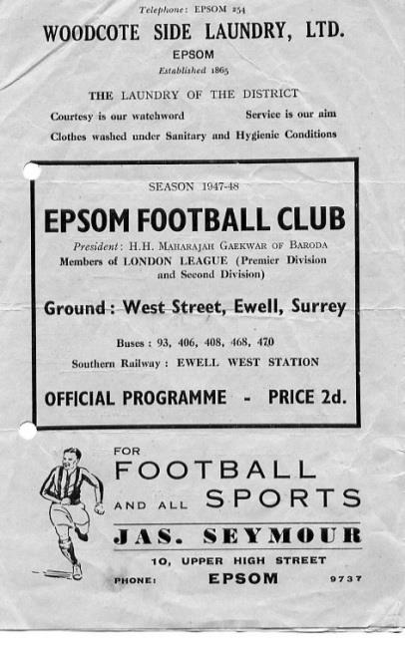
69 years ago today we departed the London League Cup by three goals to two at West Street against the Royal Naval Depot (Chatham). D.Quinn scored on his debut and the other was scored by local lad and future two-time Manager Fred Chitty. (see programme pictured).

33 years ago today we visited Kingfield the home of Woking for a League match. Woking had been relegated the previous season so would present a tough challenge, but the main concern after a torrential downpour was whether the match would even go ahead. Very little of quality occurred in the first half before we conceded early on but goals from Steve Hill and Robin Lewis gave us the win and we would be promoted at the end of the season.

30 years ago today one of our most famous players made his debut. Matt Elliott had been with our club for a couple of seasons in the Youth team and took the field at Boreham Wood’s Broughinge Road for what would become a memorable day. Memorable for nothing happening whatsoever, until Ray Metz put the ball into his own net with four minutes remaining to give the hosts the points. We would go down that season by just one point!

28 years ago today Carlton Walcott scored a hat trick in a home 3-3 draw with Petersfield United, as they were known back then. This match was one of two home matches played at Walton Road, Molesey as our lights required an upgrade. I do not recall why the lights couldn’t be replaced in the summertime!

10 years ago this week Dale Marvell scored a hat trick in a 4-4 draw at home to Raynes Park Vale at Merland Rise. This remains the last time an Epsom player scored a hat trick but didn’t finish on the winning side!

EL Records Premier Challenge Cup
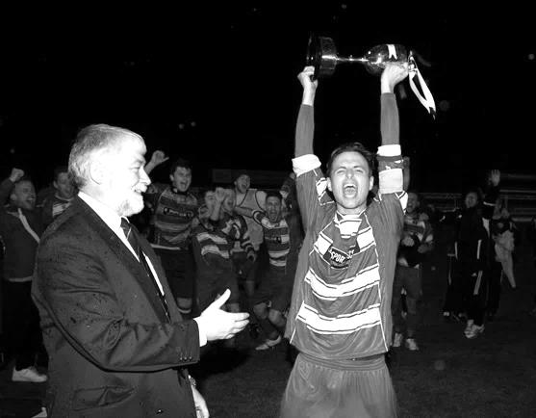
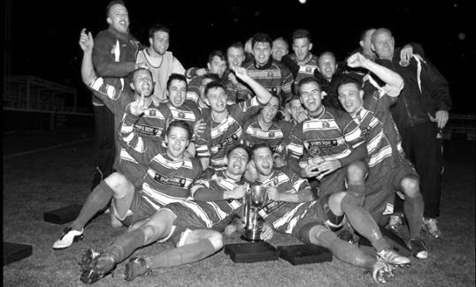
First Round
Redhill | 6/9 | Bedfont & Feltham
Spelthorne Sports | 13/9 | Sutton Common Rovers
Knaphill | 9/9 | Camberley Town
Worcester Park | 24/9 | Dorking
Epsom & Ewell | 6/9 | Abbey Rangers
Westfield | 6/9 | North Greenford United
Cobham | 6/9 | Bagshot
CB Hounslow United | 6/9 | Farnham Town
South Park Reserves | 14/9 | Balham
Second Round
Hanworth Villa | 4/10 | 5
AFC Hayes | 4/10 | 9
Epsom Athletic | 28/9 | Windsor
2 | V | Bedfont Sports
Raynes Park Vale | 4/10 | Colliers Wood United
Frimley Green | 4/10 | Banstead Athletic
6 | 4/10 | 1
Staines Lammas | 15/10 | 8
4 | V | Cove
Badshot Lea | 4/10 | Guildford City
Chertsey Town | 4/10 | 3
7 | V | Chessington & Hook United
Hartley Wintney | 4/10 | AC London
Horley Town | 4/10 | Sheerwater
Walton & Hersham | 4/10 | Eversley & California
Ash United | 11/10 | Farleigh Rovers

Surrey Senior Cup
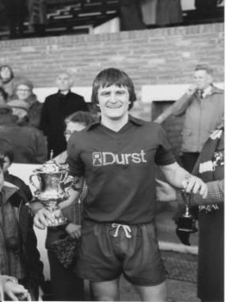
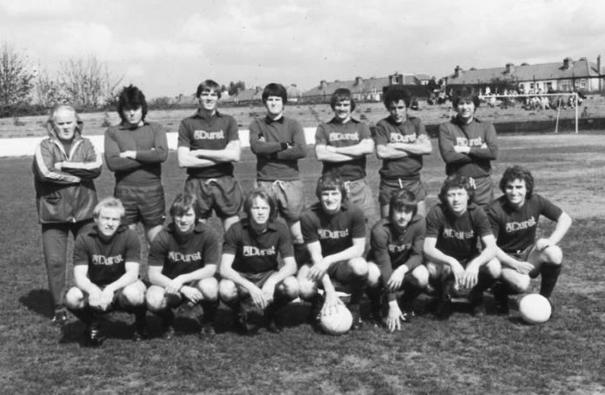
First Round
Abbey Rangers | V | AFC Croydon Athletic
Whyteleafe | V | Westfield
Second Round
Kingstonian | V | Met Police
Ashford Town (Mx) | V | Knaphill
Woking | V | Walton Casuals
2 | V | Colliers Wood United
Guildford City | V | Horley Town
Egham Town | V | Corinthian Casuals
Godalming Town | V | Merstham
Molesey | V | Leatherhead
Raynes Park Vale | V | Sutton United
Sutton Common Rovers | V | Camberley Town
Dorking Wanderers | V | South Park
Badshot Lea | V | Farnham Town
Walton & Hersham | V | Croydon
Carshalton Athletic | V | Tooting & Mitcham United
Chertsey Town | V | 1
Epsom & Ewell | V | Chipstead

Centre page for results

Centre page for results


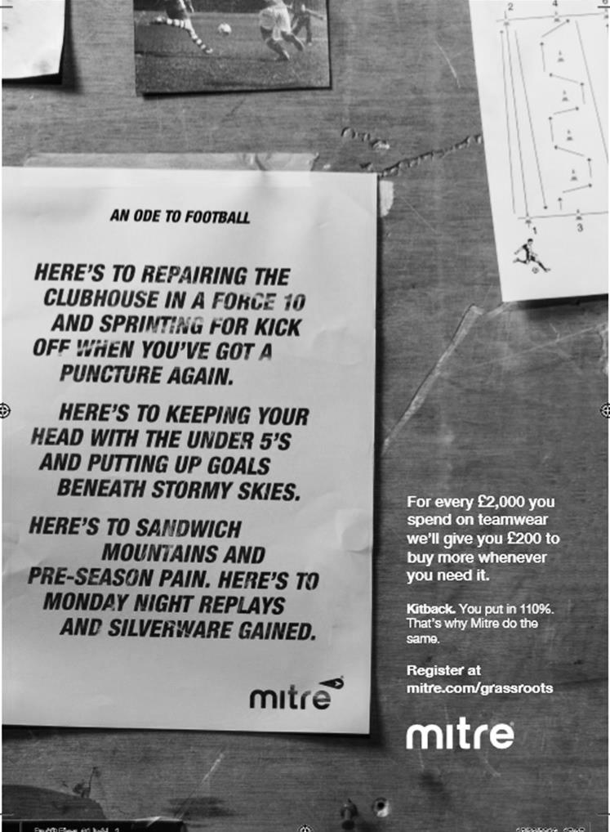

Abbey Rangers – History
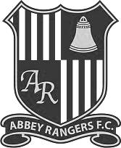
Abbey Rangers Football Club was formed in 1976 to initially promote and provide football for young boys between the ages of 6 through to 16 and taking its name from the historic Chertsey Abbey.

In the initial years Abbey Rangers had a rather nomadic existence having to use various home grounds within Chertsey and Addlestone but as the club grew in size it became clear that the club needed to plant its roots and were able to do so when we established a home on the old Meads school playing fields now known as Addlestone Moor. That ground now accommodates all formats of football from 5 v 5 up to adults.

After years of effort, the club opened up its new clubhouse in 2008, a superb and very welcoming facility partly funded by the Football Foundation. The facility was officially opened by Sir Trevor Brooking on 3rd June 2008.

The club has attained the FA Charter Community Status, and now have a healthy and growing girls and ladies section. The club also prides itself on being one of the leading lights in Surrey at providing disability football.

On the pitch, this team has made good progress over the years. After joining what is now known as the Guildford & Woking Alliance the club made big strides through the divisions and in 2008 we gained promotion to the Surrey County Intermediate League (Western) Division One winning the division at the first attempt and ensuring promotion to the Premier Division. We spent three seasons in the SCILW Premier Division finishing runners up in 2010-11 and 2011-12. After finishing runners up the 2nd time we took our place in the Surrey Elite League where we remained for three seasons finishing 5th, 3rd and 4th and winning the League cup in 2013-14.

The long term plan though for the club was always to reach the Combined Counties League and after extensive work and investment on the ground we were proud to finally be able to achieve that goal and take our place in 2015.

Our first season at this level has seen us make decent strides in the league but the clubs maiden foray in the FA Vase saw us cover some miles in reaching the 2nd round proper of that competition, the highlight being a 2-1 win at one of the pre-tournament favourites AFC Portchester. We finally succumbed to Wessex League Premier outfit Newport IOW in extra time.

Our league form improved and an unbeaten run that began at Christmas saw us finish in 3rd place and in doing so gaining promotion to the Combined Counties Premier Division at the first attempt.

This season saw another first for the club as we took our bow in the FA Cup, although it was all over very briefly as we lost 3-0 at Hellenic League Thame United.

30 years ago today!
Matthew Stephen Elliott was born in Roehampton on 1st November 1968 and moved to Epsom at an early age.
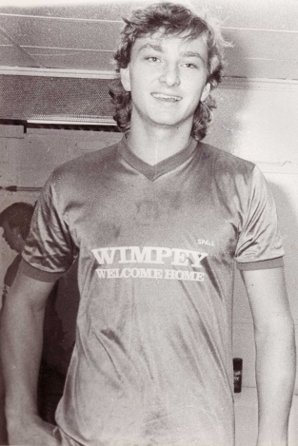
He went to Epsom High School and was two years below me. However, he was already playing for the school team at a very early age. He was of course playing kids football under the guidance of his father Alan and came to the attention of his local club, joining our youth team in the very first match of the 1983/84 season against Camberley Town in the F.A. Youth Cup at Krooner Park and had two seasons in the Youth Team also playing for the Reserves at the end of 1985.

For the 1986/87 season he was brought in for his debut by Manager Alan Webb and made his debut on 23rd August 1986 at Broughinge Road, home of Boreham Wood. He would have marked his debut with a clean sheet had fellow defender Ray Metz not inexplicably turned the ball into his own net with just four minutes remaining. We went down that year by a single point, but Elliott learned a lot alongside experienced defender Ray Purvis and in 1987/88 he kept his place, playing alongside Jimmy Richardson, following the departure of Purvis.

But as the season drew to a close, Charlton Athletic came calling. What I only found out recently was that the contact between the clubs was the Physio at The Valley at the time by the name of Jimmy Hendry! Matt played his final game for us, his 85th on 2nd May 1988 against Flackwell Heath, scoring his eleventh goal for us in a 5-1 win. He went to Charlton for £5,000 where he made just one appearance for them before moving to Torquay United where he marked Wolverhampton Wanderers International striker Steve Bull out of the game in reaching Wembley in the Associate Members Trophy.

From there he went to Scunthorpe United, also reaching Wembley Stadium in the League playoffs and scoring a penalty in the shootout which they ultimately lost. He then went to Oxford United before Martin O’Neill snapped him up for £1.6 million at Leicester City.

Matt had great success at Filbert Street, becoming Captain and scoring twice in 2000 to defeat Tranmere Rovers in the League Cup Final. By then he had also played for Scotland through a maternal grandfather and travelled to France for the 1998 World Cup, although he did not get on the pitch.

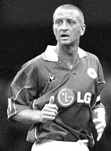
A brief spell in Management followed but Matt now works at Leicester City these days as befits a club legend. Although today’s particular milestone may not rank very highly amongst his career highlights, it means that bit more to us and is celebrated today. Thanks for the memories Matt!

Combined Counties League Premier Division Opponents
All-time Records
inc Saturday 13th August | P | W | D | L | F | A | PPG | GD | Best  Win | Worst  Loss
Bedfont & Feltham | 1 | 1 | 0 | 0 | 9 | 2 | 3.00 | +7 | 9-2 | X
Spelthorne Sports* | 5 | 4 | 1 | 0 | 15 | 6 | 2.60 | +9 | 6-2 | X
Sutton Common Rovers | 10 | 8 | 1 | 1 | 27 | 12 | 2.50 | +15 | 4-0 | 1-4
Horley Town | 28 | 19 | 5 | 4 | 62 | 30 | 2.21 | +32 | 6-0 | 1-3
Colliers Wood United | 21 | 14 | 2 | 5 | 45 | 28 | 2.10 | +17 | 4-0 | 0-3
Westfield | 18 | 11 | 3 | 4 | 39 | 29 | 2.00 | +10 | 6-1 | 0-4
Bedfont Sports | 9 | 5 | 2 | 2 | 13 | 10 | 1.89 | +3 | 3-0 | 0-4
Farnham Town | 13 | 7 | 2 | 4 | 23 | 22 | 1.77 | +1 | 3-1 | 1-4
Guildford City | 16 | 9 | 1 | 6 | 32 | 22 | 1.75 | +10 | 5-1 | 1-5
Hanworth Villa | 14 | 7 | 3 | 4 | 34 | 24 | 1.71 | +10 | 5-0 | 1-4
Raynes Park Vale | 26 | 13 | 5 | 8 | 57 | 36 | 1.69 | +21 | 6-1 | 0-2
Knaphill | 6 | 3 | 1 | 2 | 11 | 8 | 1.67 | +3 | 4-1 | 1-2
Walton & Hersham | 49 | 24 | 9 | 16 | 100 | 96 | 1.65 | +4 | 6-0 | 0-8
Camberley Town* | 88 | 38 | 21 | 28 | 158 | 123 | 1.54 | +35 | 9-1 | 0-4
Hartley Wintney | 10 | 4 | 3 | 3 | 25 | 17 | 1.50 | +8 | 5-0 | 2-4
Badshot Lea | 17 | 7 | 3 | 7 | 31 | 33 | 1.41 | -2 | 4-1 | 0-4
Windsor | 48 | 18 | 12 | 18 | 88 | 90 | 1.38 | -2 | 4-0 | 0-6
Chertsey Town | 47 | 17 | 5 | 25 | 70 | 86 | 1.19 | -16 | 3-0 | 0-7
AFC Hayes | 8 | 2 | 2 | 4 | 16 | 15 | 1.00 | +1 | 7-0 | 0-3
Abbey Rangers | 0 | 0 | 0 | 0 | 0 | 0 | 0.00 | 0 | X | X
CB Hounslow United | 1 | 0 | 0 | 1 | 1 | 2 | 0.00 | -1 | X | 1-2
Total* | 435 | 211 | 81 | 142 | 856 | 691 | 1.65 | +165 | - | -
* includes one abandoned match v Camberley and one loss on penalties v Spelthorne

CCL Premier Division Club Directory
ABBEY RANGERS Telephone: 01932-422962 - Ground: Addlestone Moor, Addlestone, Surrey KT15 2QH - Colours: Black & White Stripes/Black/Black

A.F.C. HAYES Telephone: 0208-845-0110 - Ground: Farm Park, Kingshill Avenue, Hayes, Middx. UB4 8DD - Colours: Blue and White Stripes/Blue/Blue

BADSHOT LEA Telephone: 01252-320385 - Ground: Ash United FC, Shawfield Stadium, Youngs Drive, Shawfields Road, Ash, Hampshire. GU12 6RE - Colours: Claret/White/Claret

BEDFONT & FELTHAM Telephone: 0208 890 7264 - Ground: The Orchard, Hatton Road, Bedfont, Middx TW14 9QT - Colours: Yellow & Blue/Blue/Blue

BEDFONT SPORTS Telephone: 0208-831-9067 - Ground: Bedfont Sports Club, Hatton Road, Bedfont, Middx TW14 8JA - Colours: Red & Black Hoops/Black/Red & Black Hoops

CAMBERLEY TOWN Telephone: 01276-65392 - Ground: Krooner Park, Wilton Road, Camberley, Surrey. GU15 2QW - Colours: Red & White Stripes/Blue/Red

CB HOUNSLOW UNITED Telephone: 0208 890 7264 - Ground: The Orchard, Hatton Road, Bedfont, Middx TW14 9QT - Colours: Green/Black/Green

CHERTSEY TOWN Telephone: 01932-561774 - Ground: Alwyns Lane, Chertsey, Surrey. KT16 9DW - Colours: Royal Blue & White Stripes/Royal Blue/Royal Blue

COLLIERS WOOD UNITED Telephone: 0208-942 8062 - Ground: Wibbandune Sports Ground, Robin Hood Way, Wimbledon. SW20 0AA - Colours: Blue & Black Stripes/Black/Black
EPSOM & EWELL Telephone: 01737-553250 - Ground: Chipstead FC, High Road, Chipstead, Surrey. CR5 3SF - Colours: Royal Blue & White Hoops/Royal Blue/Royal Blue

FARNHAM TOWN Telephone: 01252-715305 Ground: Memorial Ground, Babbs Mead, West Street, Farnham, Surrey. GU9 7DY Colours: - Claret & Sky Blue /White/ Claret & Sky Blue

GUILDFORD CITY Telephone: 01483-443322 - Ground: The Spectrum, Parkway, Guildford, Surrey. GU1 1UP - Colours: Red & White Stripes/Black/Black

HANWORTH VILLA Telephone: 0208-831-9391 - Ground: Rectory Meadows, Park Road, off Hounslow Road, Hanworth, Middlesex. TW13 6PN - Colours: Red & White Stripes/Black/Black

HARTLEY WINTNEY Telephone: 01252-843586 - Ground: Memorial Playing Fields, Green Lane, Hartley Wintney, Hants RG27 8DL - Colours: Orange & Black/ Orange /Orange

HORLEY TOWN Telephone: 01293-822000 - Ground: The New Defence, Anderson Way, Court Lodge Road, Horley, Surrey. RH6 8SP - Colours: Claret & Sky Blue/Claret/Claret

KNAPHILL Telephone: 01483-475150 - Ground: Brookwood Country Park, Redding Way, Lower Guildford Road, Knaphill, Surrey. GU21 2AY - Colours: Red/Black/Red

NORTH GREENFORD UNITED Telephone: 0208 422 8923 - Ground: Berkeley Fields, Berkeley Avenue, Greenford, Middx UB6 0NX - Colours: Royal Blue & White/Royal Blue/Royal Blue

SUTTON COMMON ROVERS Telephone: 01932-866386 - Ground: Sutton United FC, Gander Green Lane, Sutton, Surrey SM1 2EY - Colours: Yellow/Black/Black

RAYNES PARK VALE Telephone: 020-8540-8843 - Ground: Prince Georges Playing Field, Grand Drive, Raynes Park, London. SW20 9NB - Colours: Blue/Blue/Red

SPELTHORNE SPORTS Telephone: 01932-961055 - Ground: Spelthorne Sports Club, Staines Road, Ashford Common, Ashford, Middx. TW15 1RY - Colours: Light & Dark Blue/Dark Blue/Light Blue

WALTON & HERSHAM Telephone: 01932 245263 - Ground: Stompond Lane, Walton on Thames, Surrey KT12 1HF - Colours: Red/Red/Red

WESTFIELD Telephone: 01483-771106 - Ground: Woking Park, Kingfield Road, Woking, Surrey. GU22 9BA - Colours: Yellow/Black/Black

WINDSOR Telephone: 01753-860656 - Ground: Stag Meadow, St Leonards Road, Windsor, Berks SL4 3DR - Colours: Red/Red/Red

Every Opponent A-Z
Over the years we have played many, many different opponents. Exactly how many is a difficult question, as it all depends on your definition. Are Camberley & Yorktown different to Camberley Town, or are Epsom Town different to Epsom F.C. or Epsom & Ewell F.C.?

In my analysis I have classed them as the same team, and will work through them all from A to Z. Some we have played many times, whilst others we have met just once or twice. Enjoy!

St Francis Rangers: Played 1 - W0 D0 L1 - F1 A2 - PPG - 0.00

The Colwell Ground, former home of Sussex League side Ansty Rangers and nowadays home to St Francis Rangers is a picturesque venue with the imposing backdrop of the former Princess Royal Hospital and has impressive views across the county.

Unfortunately that was about the only redeeming feature about our trip there on 1st September 2012, when we dominated for a large part of the game only to lose 2-1 and add the match to our growing file marked “Huge F.A. Vase disappointments”. We went into the match with high hopes after realising that they only got about one point all of the previous season but our keeper Colin Harris was caught out by a long range shot early in the match that dipped viciously and we conceded a second towards the end. A late Charlie Shaw header ensured a frantic last few minutes but we were unable to force extra time.

We have visited them for a friendly at the start of 2014/15, winning 3-2 and had to cancel one the following season when unable to raise a team for the trip. However, St Francis now find themselves in Step Six after another awful season left them well adrift and there are rumours about their future existence. I hope they survive.

St Neots Town: Played 1 - W0 D0 L1 - F1 A2 - PPG - 0.00

Just two seasons before playing at St Francis we played another F.A. Vase match but in completely opposite circumstances. Our Fourth Round run the previous season had earned us a bye to the Second Round where we then defeated Bracknell Town 4-0 on a Sunday at our temporary home in Merstham to progress to the Third Round. All we needed was a decent draw to reach the fourth round and gain another exemption when news came out that we had drawn the favourites for the competition, St Neots Town.

St Neots had recently reformed after going bust in the nineties but they had plans on a grand scale. They were top of their League by a street, had their own TV station and separate 3g Astroturf pitch amongst other state of the art fixtures including an enormous television screen in the clubhouse. We hoped that there would be a decent attendance but even that was dashed by a snow postponement on the Saturday and when the game was eventually played on the Tuesday 14th December 2010 it caught many by surprise and of course affected the gate.

They had some big names like former Aston Villa player Stefan Moore in their line-up but young defender Anthony Panayi kept him quiet and when Dave Stevens put us ahead on a frozen Moatside evening you dared to believe.

Of course it couldn’t last and we hardly saw the ball in the second half, losing 2-1. Oddly enough they didn’t win the Vase though, beaten by a reformed Kings Lynn team that was in the same league as them. Nowadays, they play at Step Three in the Southern Premier League and having been there in recent years, I can confirm that they now have a very impressive set up indeed.

Staines Town: Played 12 - W3 D3 L6 - F13 A19 - PPG - 1.00 - Poor

We have met Staines Town sporadically over the last forty-five years, with a match here and there as we occasionally kept company in the same league as them. Our first meetings came in the 1971/72 season. We were a poor Athenian League Division Two team and they dropped from the division above, but bounced straight back as Champions, losing just once all season while we were bottom of the league for the second time in a row. We lost 3-1 at Wheatsheaf Lane in our first ever meeting on 21st August and 2-1 in the return at West Street on 4th March.

We went up to the Isthmian League Premier Division in 1984 but Staines were demoted for ground reasons. We still met in the Isthmian League Cup Quarter Final on 14th March 1985 at West Street but were defeated 1-0 after extra time on a freezing night by a very special strike, I recall.

When we were relegated in 1986 we met as league equals once again in the First Division. We drew 2-2 at West Street but on 31st January of 1987 produced a great performance to win there 3-0 in our battle against relegation with two goals from the newly rejoined Steve Hill and one from Alex Mair. We still went down though!

Our next meetings came 12 years later in the 1999/00 season again in the Isthmian League Cup, where we held them to a very creditable 1-1 draw at Merland Rise after extra time, in fact we led through Simon Hatton’s great strike for quite some time in that match before a late equaliser forced the extra period. Seven days later on 21st September 1999 we lost the replay 3-0.

This time we only had to wait three seasons before our promotion to Isthmian Division One South where we met in the league again. First though we had to go there in the F.A. Trophy. In a match played at Egham Town as Wheatsheaf Lane was being redeveloped, we trailed before fighting back to equalise through James Hall and Richard Ingham secured a late winner that sent us to Newport County in the next round. Our League meetings came at the end of the season, on 11th March, when we secured a fine 2-2 draw in the first midweek match at the newly improved ground and we followed this with a 1-0 win, courtesy of Simon Huckle on 19th April. Relegation followed the season after this and we lost 2-0 home and away on our way down, with the last match taking place on 24th January 2004.

Since then they have gone from strength to strength and have spent much time in the Conference South, even having time for a decent F.A. Cup run to the second round, aided by former Salt Adrian Toppin. They are now back in the Isthmian League but are clearly intent on returning at the first attempt, as evidenced by their 6-1 win at Met Police ten days ago to open the season.

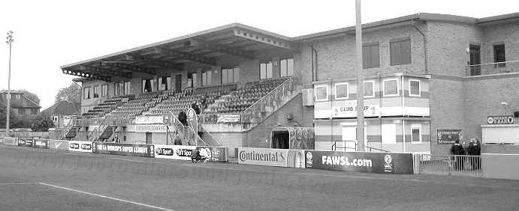
The new structure of main stand and leisure centre at Wheatsheaf Park

Player Sponsorship
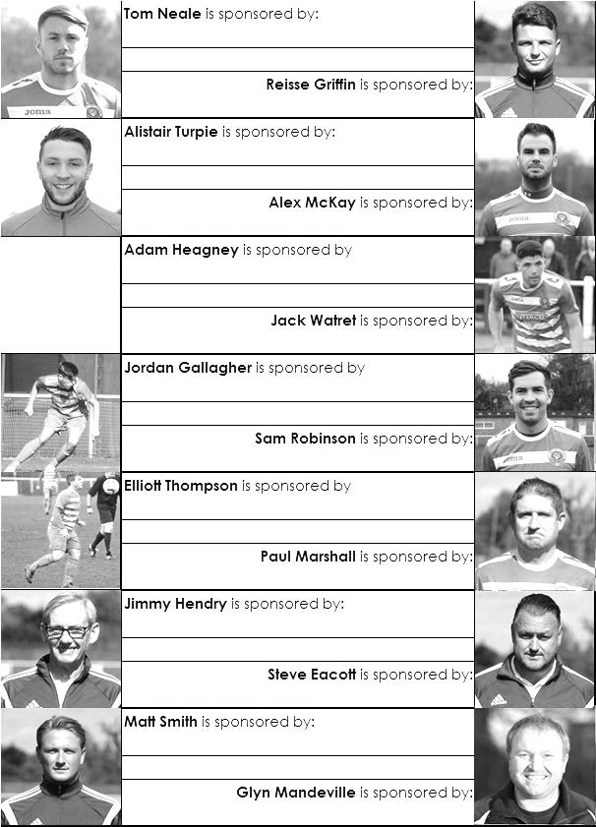

Here is the opening list for the 2016/17 season showing all of our players and Management that are currently available for sponsorship.

Sponsorship costs just £40 and it is easy to do. Just select a player who has not been previously sponsored and let a Committee Member know that you would like to sponsor them. Beware though. Until we have received the money it is possible for someone to jump in front of you, so don’t delay, sponsor today!
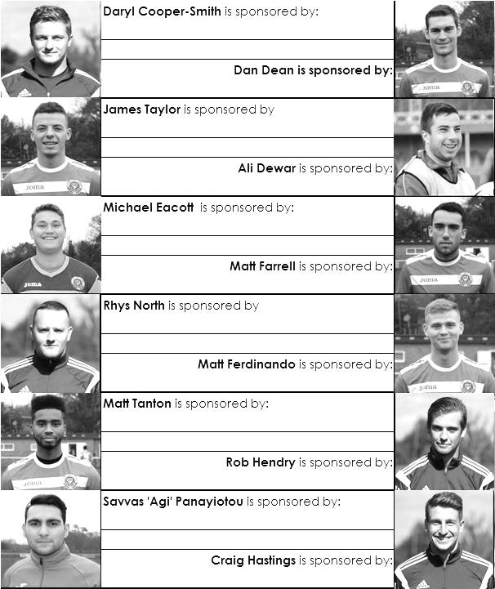

Match and Ball Sponsorships – 2016/17
Opponent | Date | Match Sponsor | Ball Sponsor
Gravesham Borough | 07/08/16 | Club President - Stella Lamont
Gravesham Borough | 07/08/16 | Relocation Committee Member - Mike Lovett
CB Hounslow United | 16/08/16 | EEFC Management Committee
Abbey Rangers | 23/08/16 | Steve & Geoff Dyke
Horley Town (11.30am) | 29/08/16 | In Memory of Chris Henry
Abbey Rangers (LC) | 06/09/16
Camberley Town | 10/09/16
Guildford City | 13/09/16
Knaphill | 24/09/16
Sutton Common Rovers | 08/11/15
Windsor | 15/11/16
Bedfont Sports | 19/11/16
AFC Hayes | 26/11/16
Hanworth Villa | 13/12/16
Chertsey Town | 17/12/16
Raynes Park Vale (11.30am) | 27/12/16
Spelthorne Sports | 07/01/17
Bedfont & Feltham | 21/01/17 | Programme Editor - Richard Lambert
Badshot Lea | 04/02/17
Westfield | 18/02/17
Walton & Hersham | 04/03/17
Hartley Wintney | 18/03/17
Farnham Town | 25/03/17
Colliers Wood United (1.00pm) | 14/04/17 | Good Friday match – make a note!
North Greenford United | 22/04/17
 | tba | F.A. Vase – if drawn at home
Chipstead (SSC) | tba
For League, League Cup and Surrey Senior Cup Matches:
Match sponsorship - £40.00 Match ball sponsorship - £25.00. Combined £55.00.
For F.A. Cup and F.A. Vase matches:
Match sponsorship - £50.00 Match ball sponsorship - £30.00. Combined £65.00.

Sponsorship includes: (x2 for match, x3 for match and ball)

Admission, programmes, hospitality and advertising and mascot for the day (if required).
If you are interested, just speak to a Committee Member, or drop me an email at: richard.c.lambert@gmail.com


We also thank our Kit Sponsors INTERCEM

Salts Super Six Predictor
The Salts Super Six Predictor is live again for this evening’s match and the tickets are on sale at today’s game to the left of the gate.

The competition is easy to play and you don’t even have to be at the match! To win, you simply need to predict the results of six matches correctly from the three options, fill in the form and make sure it is back with one of our distributors before the deadline on the ticket. The latest fixtures are shown here and are a bit of a mixed bag to be honest!

If you are a club regular, you just need to place your name on the sheet, although if you aren’t, then we’ll need a contact number from you too. We will announce any winners on the website within three working days, so don’t worry, we won’t miss you!

We had a big jackpot winner last year and who knows how much could be won this time! It is currently £88 and you’ll always know the size of the pot before you enter.

Please note that if there is more than one winner, the prize pot would be shared between the winners. All you need to do now is have a go, as many times as you like!

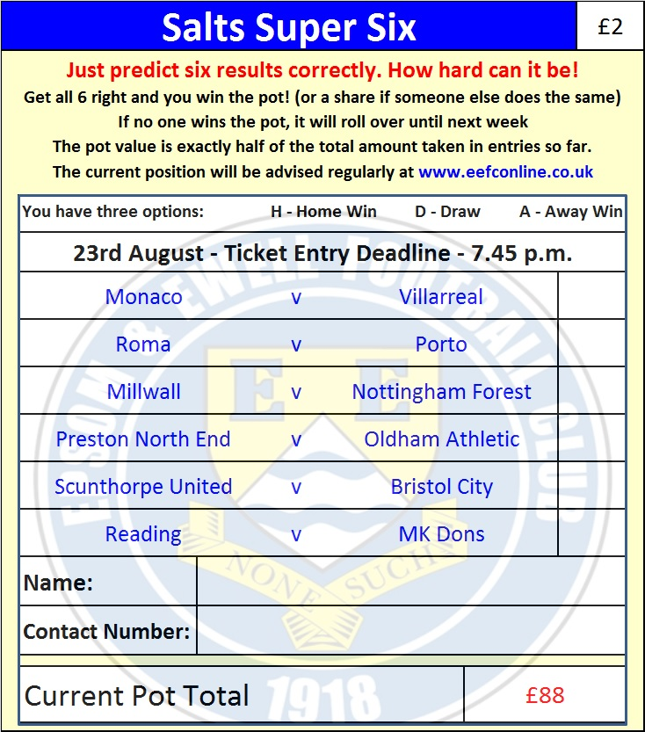

Good luck!

Combined Counties League – Premier Division
Tuesday, 23rd August 2016 - Kick-off 7.45 p.m.
Epsom and Ewell  (Royal Blue & White hoops) | V |  | Abbey Rangers  (Black and White/Black/Black)
Squad | NUMBERS
Michael Eacott |  |  | Liam Stone
James Taylor |  |  | George Davies
Matt Tanton |  |  | James Shannon
© Dan Dean |  |  | Dale Webb
Craig Hastings |  |  | Tom Bentley
Sam Robinson |  |  | Joe Macklin
Rob Hendry |  |  | Marcus Aristide
Matt Farrell |  |  | John Sherratt
Tom Neale |  |  | Tom Arnold
Daryl Cooper-Smith |  |  | Nick Ford
Reisse Griffin |  |  | Ben Kersley
Matt Ferdinando |  |  | Sam Workman
Rhys North |  |  | Jason Robertson
Alex McKay |  |  | Luke Robertson
Jordan Gallagher |  |  | Dariush Noonan
Elliott Thompson |  |  | Elliott Firth
Alistair Turpie |  |  | Michael Carey
Savvas ‘Agi’ Panayiotou |  |  | Danny Hartlebury
Adam Heagney |  |  | Paul Hodges
Sal Manu |  |  | Alex Jackson
Glyn Mandeville | MANAGER |  | Les Chatfield
Matt Smith | ASSISTANT
Steve Eacott / Alex McKay / Jimmy Hendry | COACHES / PHYSIO |  | Paul Johnson / Mickey Woolgar
REFEREE: A.Higgs
ASSISTANTS: K.Corrick, R.Wells
Today’s Match and Match Ball are sponsored by:
Steve and Geoff Dyke

OUR NEXT VISITORS TO HIGH ROAD
Horley Town
Combined Counties League – Premier Division
Monday 29th August 2016 – 11.30 a.m.

